| **Job Sheet** |
| --- |

| **Module** | **:** | IoT Fundamentals | **Module Code** | **:** | EC33105FP | |
| --- | --- | --- | --- | --- | --- | --- |
|  |  |  |  |  |  | |
| **Job No** | **:** | 4 | **Duration** | **:** | F/T: | 3 hours |
|  |  |  |  |  | P/T: |  |

| **Job Title** | **:** | Integrate Sensor - Part 1 |
| --- | --- | --- |
|  |  |  |
| **Objectives** | **:** | 1. Prepare RPi and Upswift 2. Connect Ultrasonic 3. Execute program to get distance data |

**Tools, Equipment and Materials**

| PC |
| --- |
| RPi with microSD |
| RPi Power Adaptor  HC-SR04+ x 1  1 kohm x 3  Breadboard  4G WiFi Router |
|  |

**Number of Tasks to Complete**: 4

**Part A: Prepare RPi and Upswift (0.5 hour)**

Before performing any hardware configurations, we need to ensure that the RPi is accessible remotely.

YOU MUST HAVE COMPLETED JOB 1 BEFORE DOING THIS

**Task 1 – Prepare RPi and UpSwift**

Perform the following steps to setup RPi:

1. Connect only the power adaptor to RPi.
2. Turn on the power
3. Go to <https://dashboard.upswift.io/dashboard/> and login. The device would be **offline**.

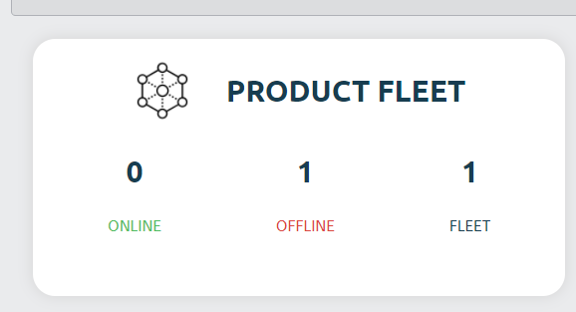

1. Wait for a while and refresh the web page by clicking . Device should appear online after 1 - 2 mins.

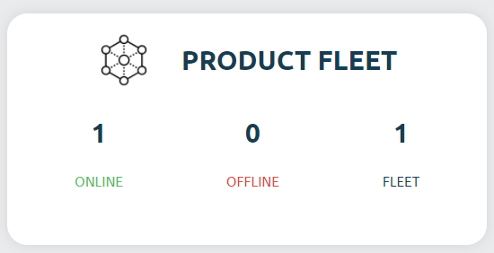

1. On the left side of your menu, click on the **Control** option under Control center.



1. On the page center, select your device and click open session.

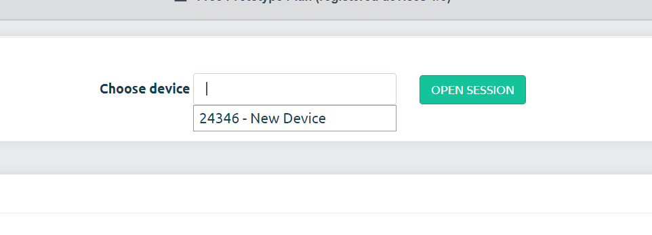

1. For the prompt, click **Open Remote Control.**

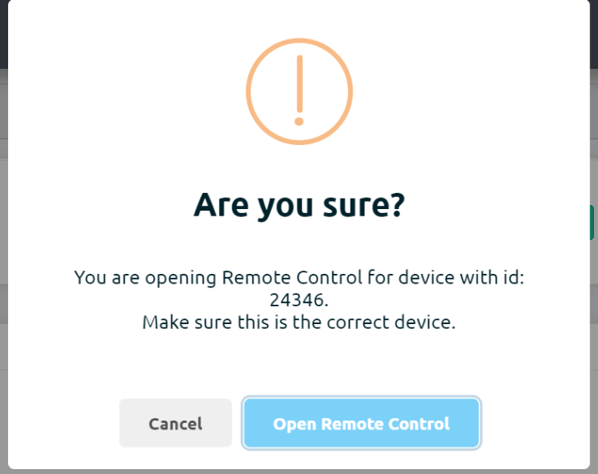

1. You will be shown a secret key. Click on **Copy to clipboard** button

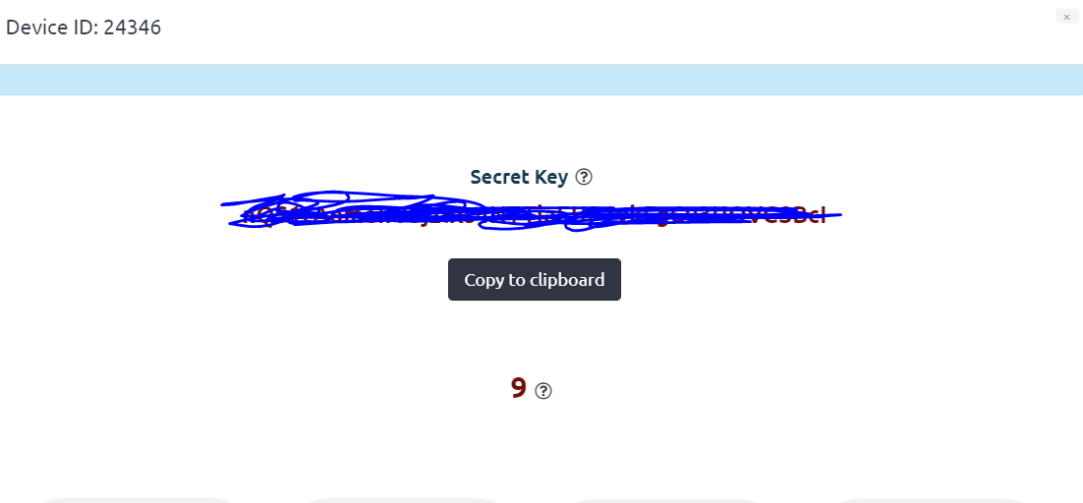

1. Once the timer is up, click on the **Open Remote Control** button.



1. **Paste** the secret key in the input text box and change username to pi. Click on **Connect**.

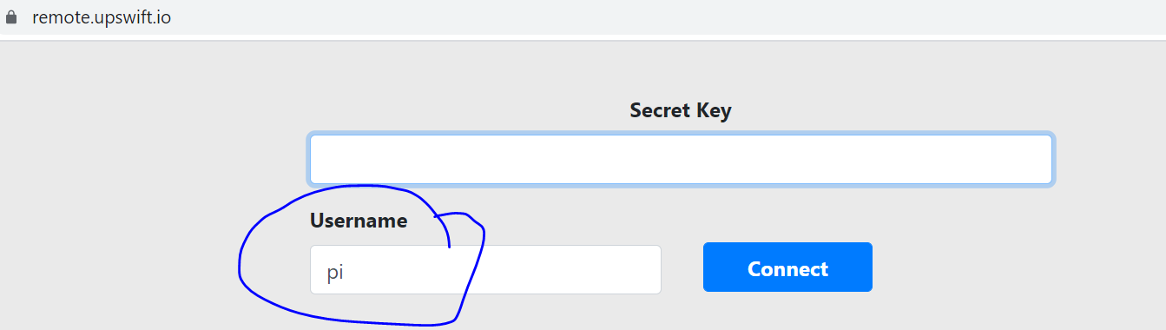

1. You will be presented with a browser based RPi terminal.

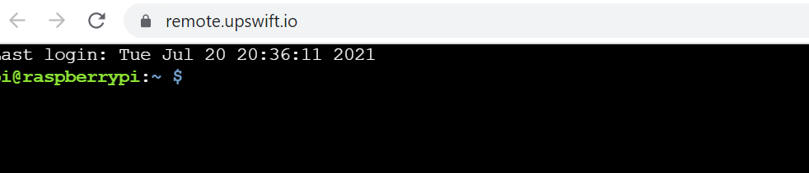

**Part B: Connect Ultrasonic**

Connect the ultrasonic sensor (HC SR04) to the RPi’s GPIOs following the schematic below.

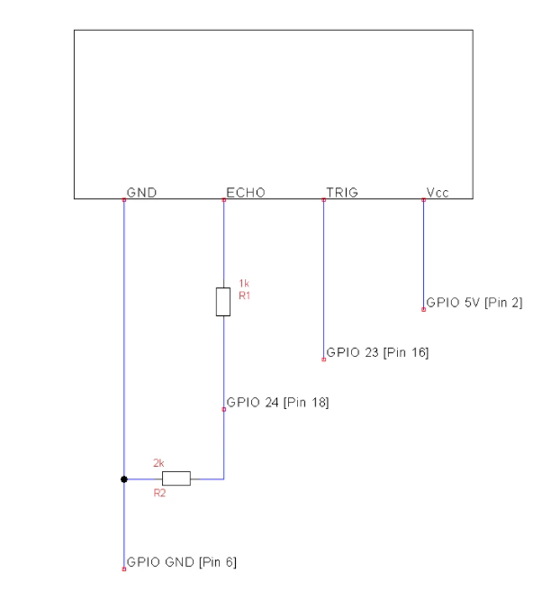

**Task 2 – Connect Ultrasonic**

Perform the following steps

1. Connect Ultrasonic Vcc to GPIO 5V (Pin 2).
2. Connect Ultrasonic TRIG to GPIO 23 (Pin 16).
3. Connect Ultrasonic ECHO to 1k resistor.
4. Use two 1 k resistors in series to form a 2 k resistor.
5. Connect 2k resistor to 1 k resistor and GPIO 24 (Pin 18).
6. Connect 2k resistor to Ultrasonic GND and Ultrasonic GND to RPi GPIO GND.

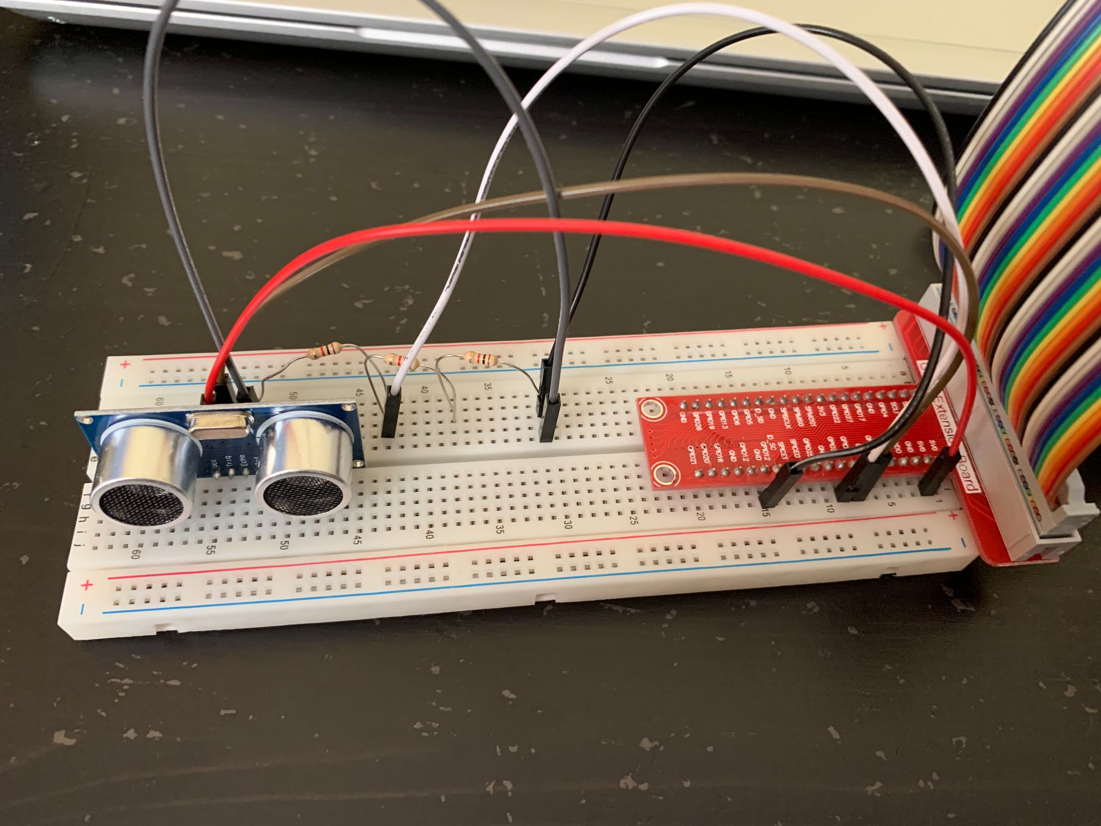

**Part C: Execute program to get distance**

The RPi will send a trigger signal on GPIO 23. The ultrasonic sensor then sends a wave and measures the echo from any object present in front of it, if any. This echo will be sent as pulses to the GPIO 24 and the program will measure the time and calculate the distance.

**Task 3 – Execute program**

1. Run **sudo nano job4.py.**



1. Copy the code found at <https://github.com/Prakashash18/iot-fundamentals/blob/main/job4.py>
2. Paste it into the nano editor by right clicking and pasting.

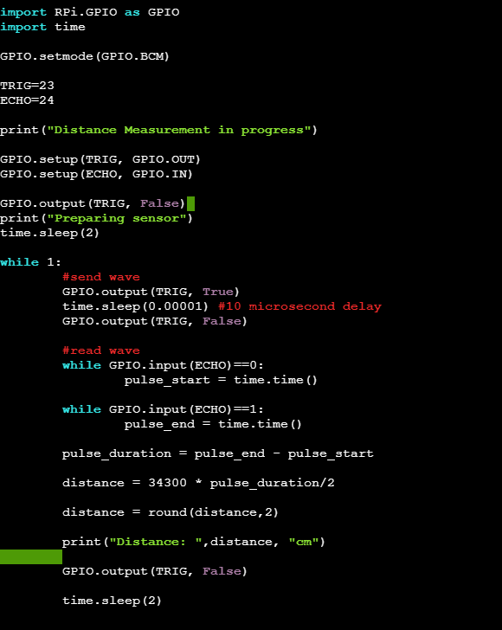

1. [Keyboard] Press CTRL + X to save your work. You will be prompted with the following message.

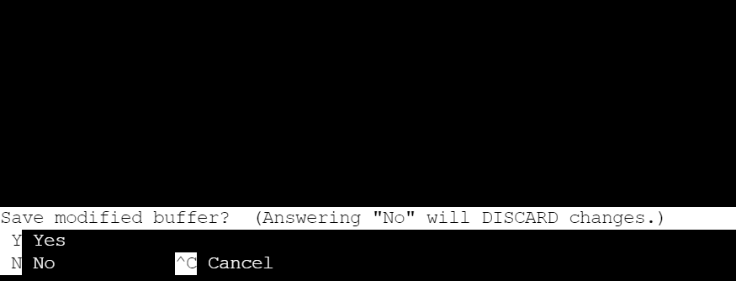

1. [Keyboard] Press **y** for yes and hit **Enter**
2. On the terminal, run **sudo python3 job4.py** to execute the code. Note that we are using python version 3.
3. You should see the distance readings.

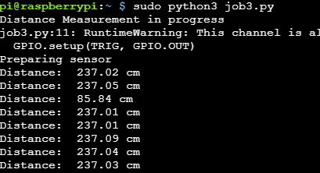

**Task 4 – Work Challenge**

You are working at AB Robotics Pte Ltd as a technician. You are part of the team monitoring the industrial robots. The current system only provides the distance.

The robot is supposed to warn **“Object too near”** if any object comes <= 5 cm.

Else, the robot should say **“Object not near”**.

You are asked to **edit a program such that the following messages are shown. Example below.**

*Hint, you need to add an if else condition in python.

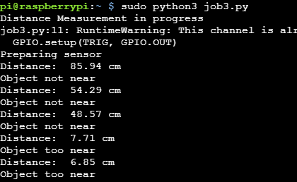

**Questions**

Refer to HC SR04 datasheet online for these questions.

The datasheet can be found here:

<https://cdn.sparkfun.com/datasheets/Sensors/Proximity/HCSR04.pdf>

1. What is the max distance supported by the HC SR04 ?



1. What is the duration of the trigger pulse ?



1. What is the theoretical ranging accuracy ?

